LAB ASSIGNMENT 1 (UG/02/BTCSEAIML/2023/065)

Write down all the linux commands.
- Opening linux then “kex –win” and put the “password” then right click the screen and full screen clicked off . Open the terminal there and code bash . Then code “man ls” to get:
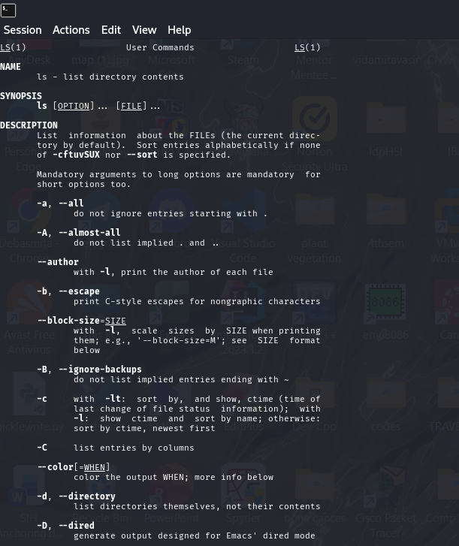
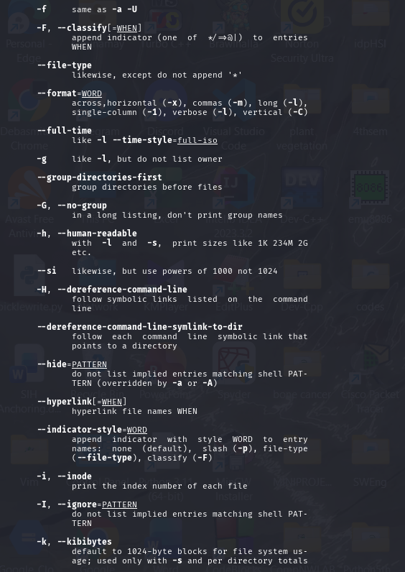
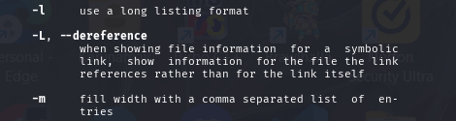
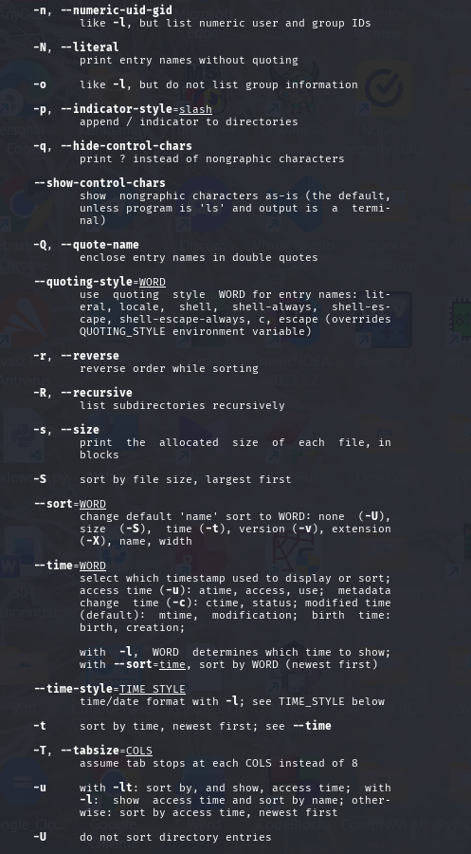
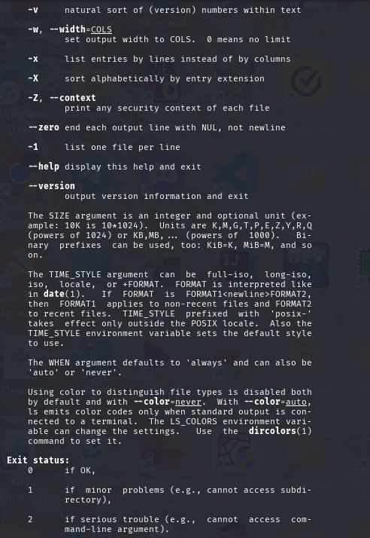
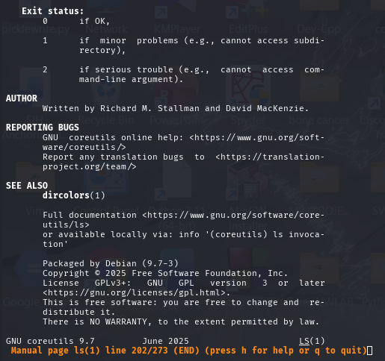

Now code with “man grep”
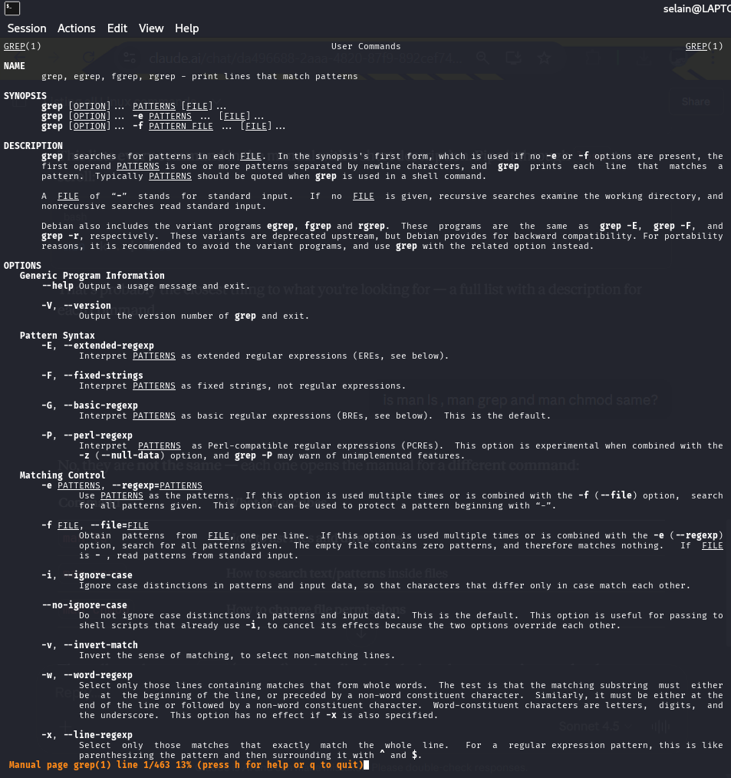
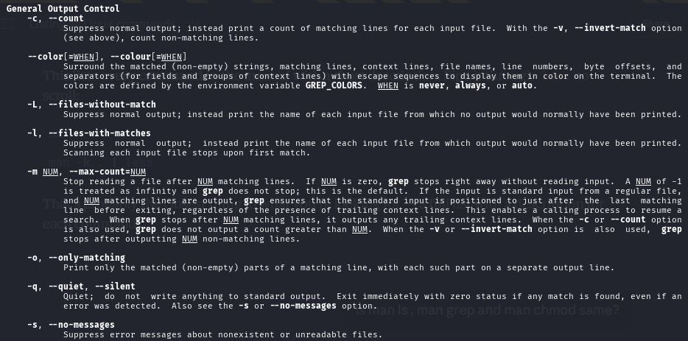
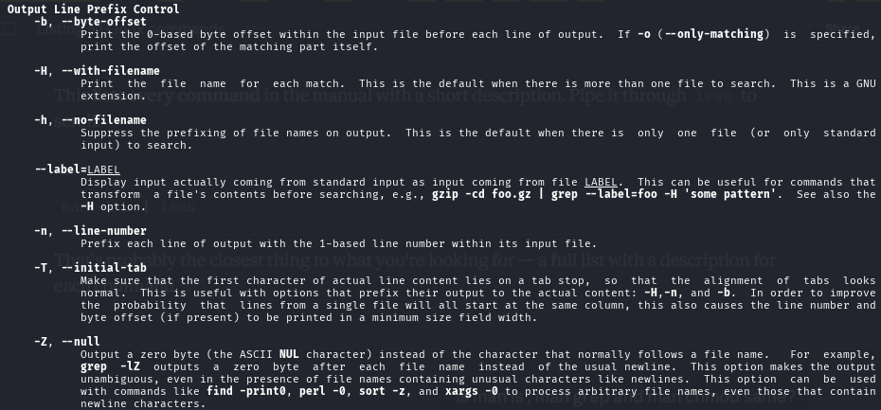
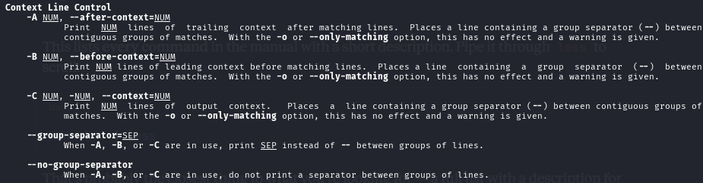
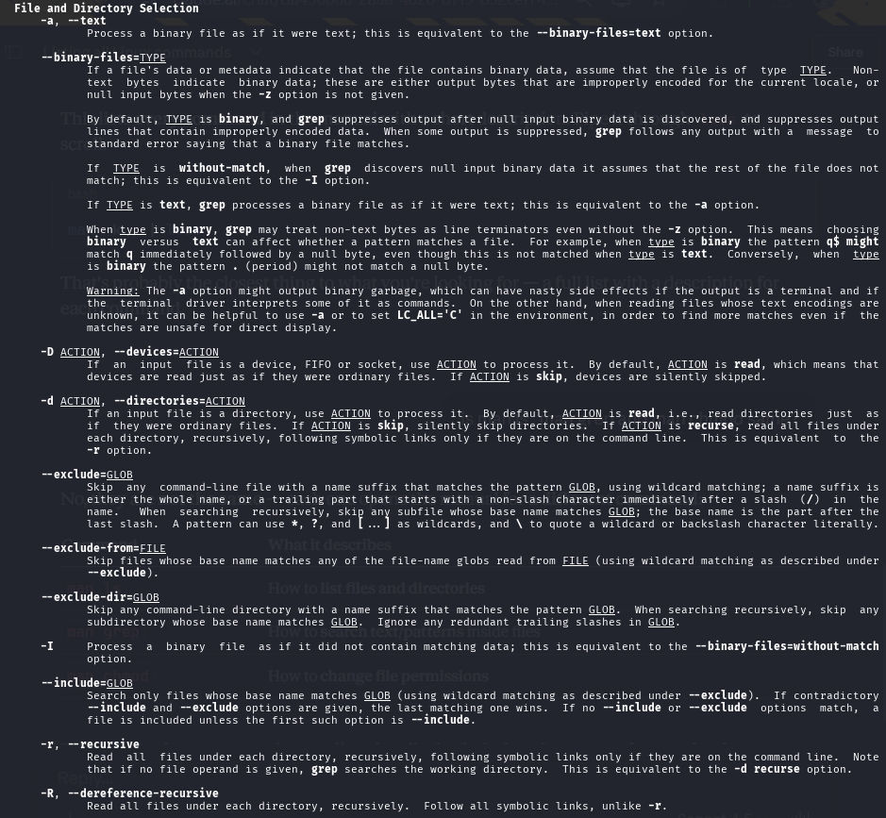
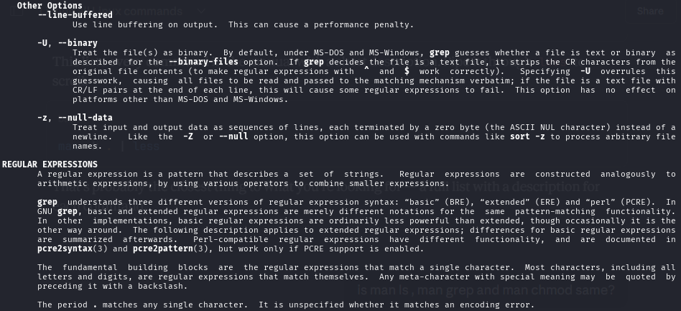
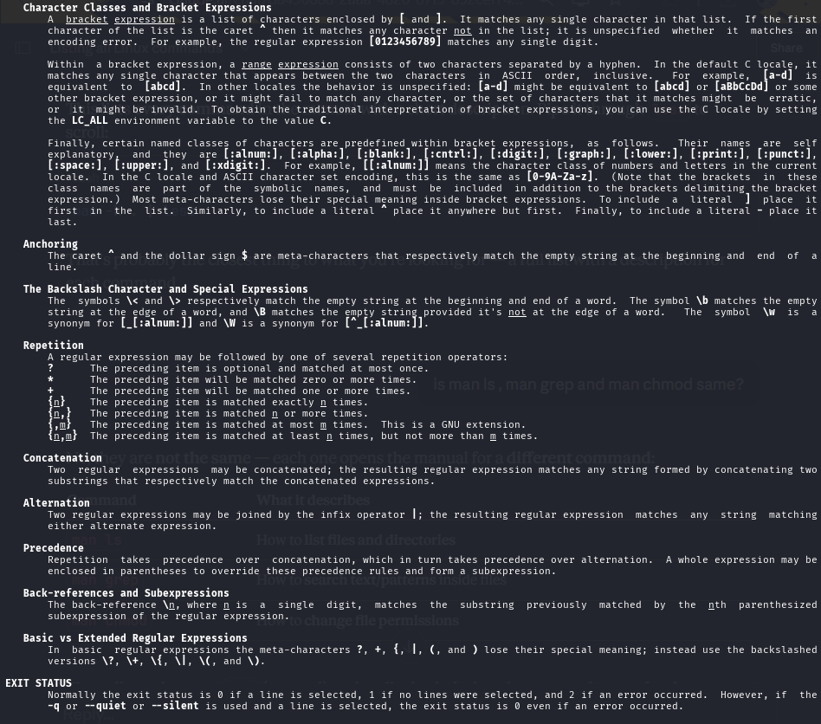
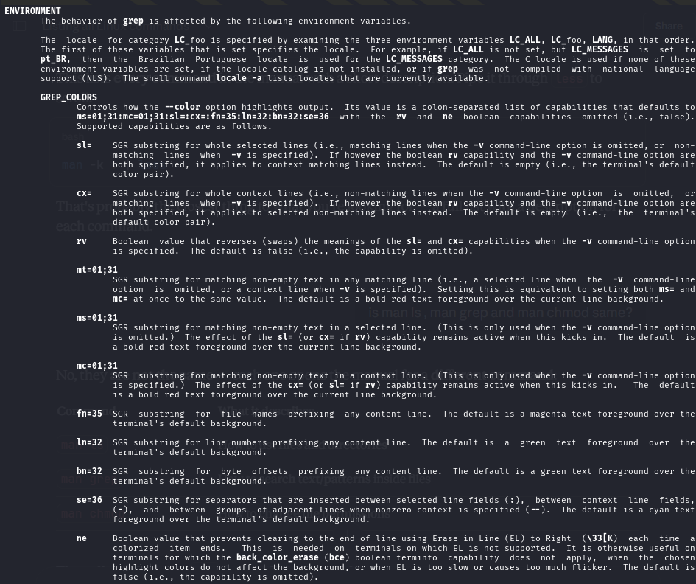
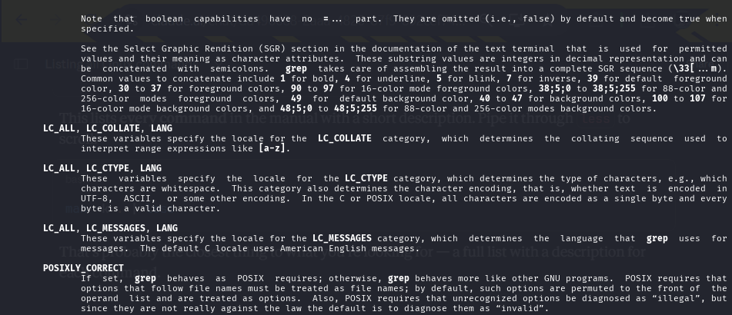
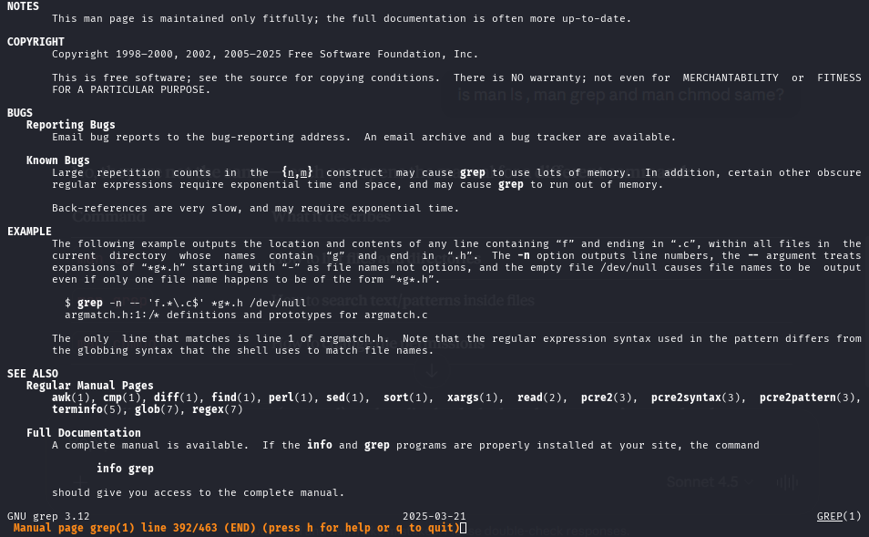
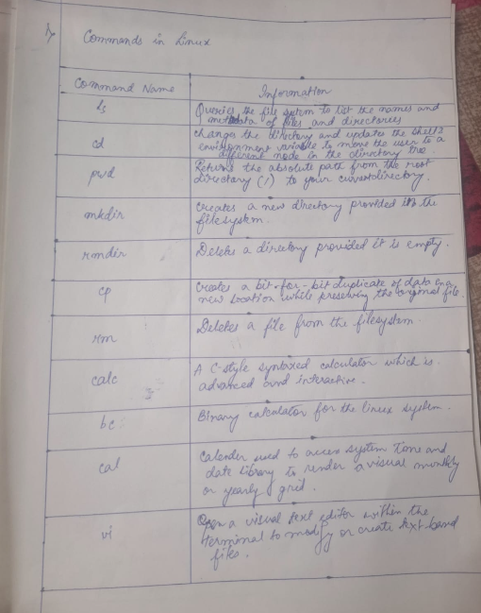

NOW using “man chmod”
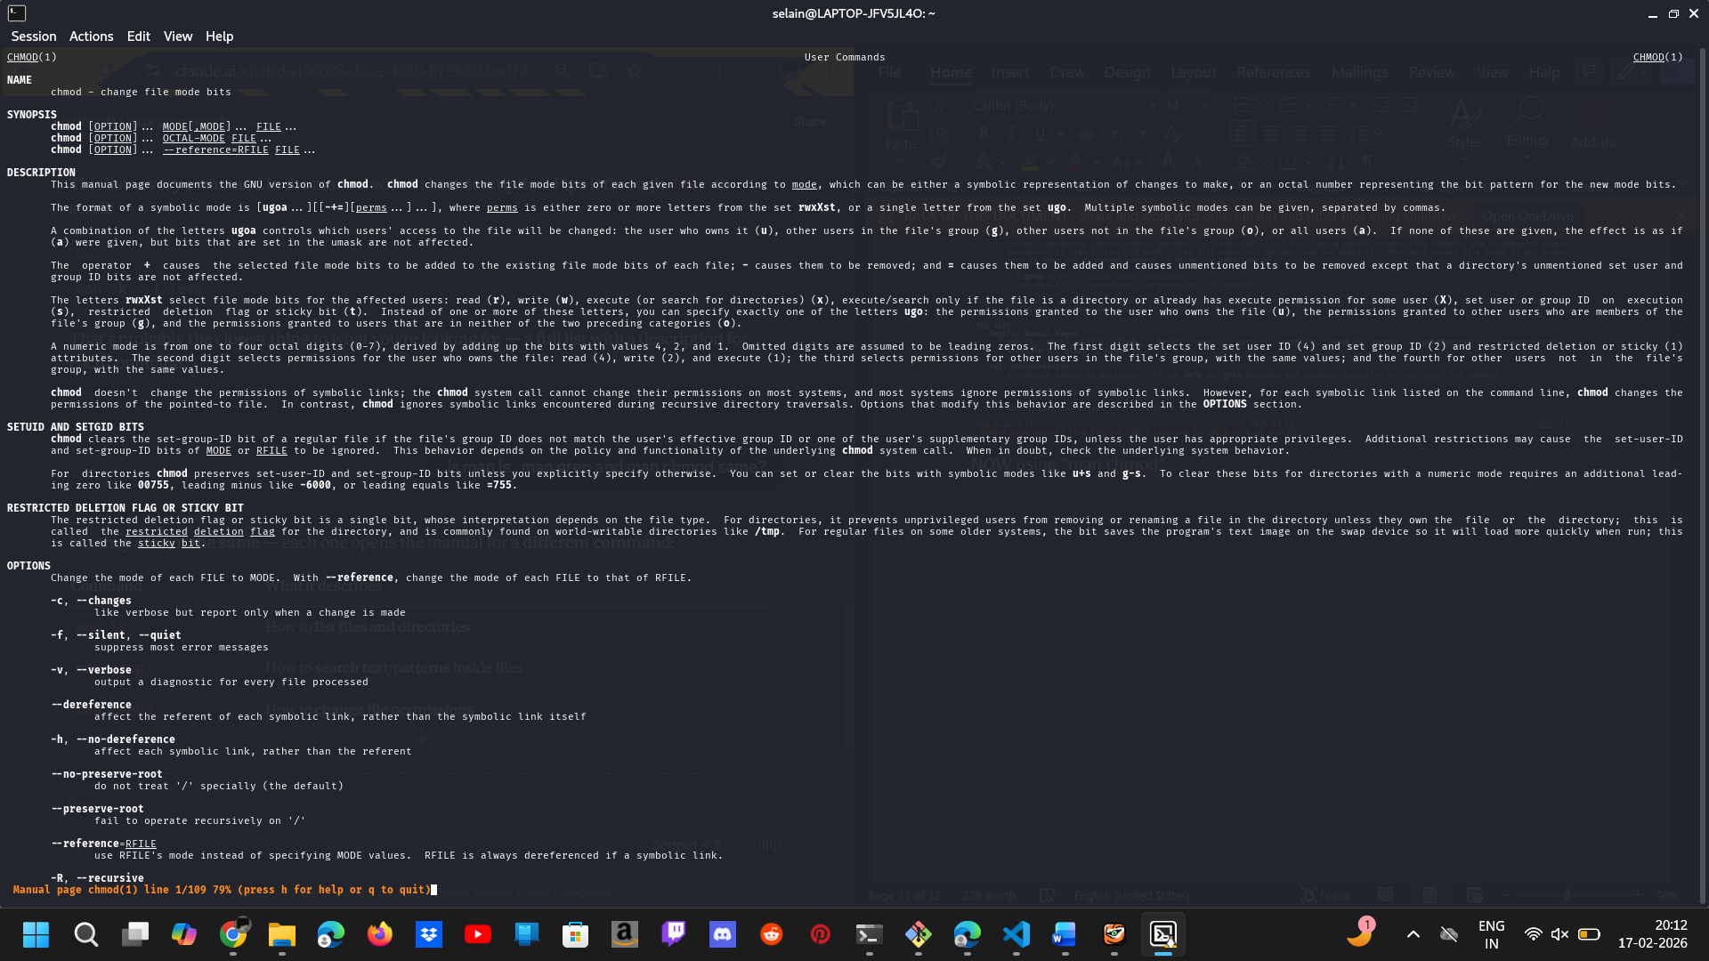
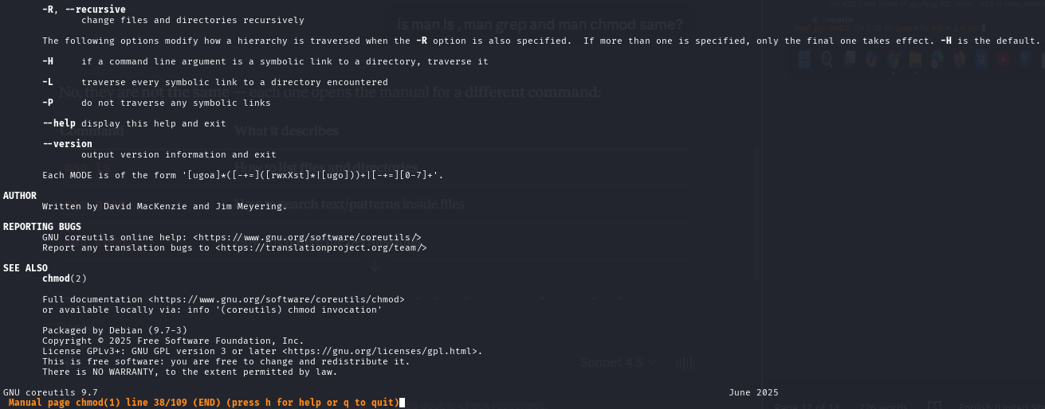
No, they are not the same — each one opens the manual for a different command:
Command | What it describes
man ls | How to list files and directories
man grep | How to search text/patterns inside files
man chmod | How to change file permissions
They all use the same man (manual) tool to display help, but the content is completely different because they are three different commands with different purposes.
Think of man like a dictionary — the dictionary itself is the same, but each word you look up gives you a different definition.
For example:
man ls will tell you things like:
- ls -a → show hidden files
- ls -l → show detailed list
man grep will tell you things like:
- grep -i → ignore case
- grep -r → search recursively
man chmod will tell you things like:
- chmod 755 → set read/write/execute permissions
- chmod +x → make a file executable
So the syntax is the same (man + command name), but each one opens a completely different manual page for that specific command.

